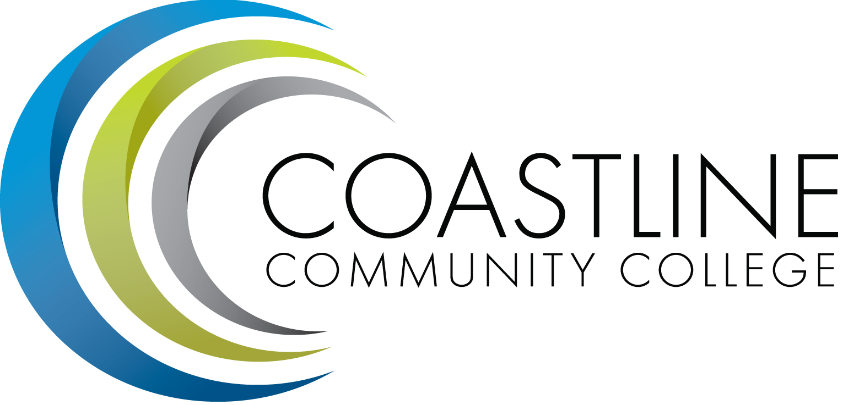
Coastline Management Meeting (CMT) Agenda
November 7, 2017
9:00 – 11:00 a.m.
College Center - 4th Floor Conference Room

Committee Mandate: To review and improve College operations and management through sharing information, discussion, and staff development.

- CALL TO ORDER
  - Roll Call
  - Welcome
  - Adoption of Agenda
  - Approval of Minutes
- *July 19, 2017 ( Special CMT Meeting)
- *August 1, 2017
- *September 5, 2017
- SPECIAL REPORTS & UPDATES (15 minutes per)
2.1 Luminis/MyCCC and Single Sign-On - Rupa Saran, Sr. Director IT Applications & Development

- ACTION ITEMS
  - From September 5, 2017 Meeting (new items):
3.1.1 Vince and Danny Pittaway will provide a report and summary of the Accreditation Standards work completed to date.
- STANDING REPORTS (2 minutes per)
- Accreditation – V. Rodriguez
- PIEAC – S. Barnes, V. Rodriguez
- Budget – C. Nguyen
- Academic Senate – S. Barnes
- Classified Senate – K. Hipp
- Associated Student Government (ASG) – N. Brais
- President’s Report – L. Adrian
- Executive Team Report – J. Groot, C. Nguyen, V. Rodriguez
- HR Report – R. Akins
- Financial Aid Federal Program Review Update
- DISCUSSION ITEMS
5.1 Serving the homeless
5.2 Work Hours
5.3 *AP/BP 3900 – Speech: Time, Place, Manner
5.4 2018 Managers Retreat
5.5 Spring 2018 Classified Flex/All-College Meeting

- HOT TOPICS

- ANNOUNCEMENTS

- ADJOURNMENT

9. CDMA – CLOSED SESSION

*Attachment
Next Meeting: December 5, 2017

